Drivers

1. Scale
2. Security
3. Constrained Devices and Networks
4. Data
5. Legacy Device Support
6. Real time analysis

1. **Scale:**

- **Explanation:** IoT systems often involve a massive number of devices and generate vast amounts of data. Scalability is essential to ensure that the architecture can handle the growth in device count and data volume over time.

- **Example:** A smart grid network includes millions of IoT devices like smart meters, grid sensors, and switches. The IoT architecture must scale to accommodate the increasing number of devices and the real-time data they generate as the grid expands.

2. **Security:**

- **Explanation:** Security in IoT architecture is vital to protect devices, data, and communication channels from various threats, including unauthorized access, data breaches, and cyberattacks.

- **Example:** In a connected car system, security measures are critical to prevent malicious actors from gaining control over the vehicle's functions, like braking or acceleration. Encryption, secure boot processes, and intrusion detection are essential security components.

3. **Constrained Devices and Networks:**

- **Explanation:** Many IoT devices have limited processing power, memory, and energy resources. IoT architectures must be designed to work efficiently with these resource-constrained devices and often unreliable, low-bandwidth networks.

- **Example:** In agricultural IoT, battery-powered soil moisture sensors operate in remote fields with minimal network connectivity. The IoT architecture should be resource-efficient to maximize sensor battery life and transmit data over low-power, long-range networks like LoRaWAN.

4. **Data:**

- **Explanation:** IoT data comes in various formats, and the architecture needs to manage, store, process, and analyze this data effectively to derive insights and make informed decisions.

- **Example:** In a healthcare IoT application, patient monitoring devices produce a constant stream of vital sign data. The IoT architecture should include data preprocessing and analytics capabilities to identify critical trends, anomalies, and patient alerts in real-time.

5. **Legacy Device Support:**

- **Explanation:** Many existing devices may not be IoT-enabled and require adaptation or integration into modern IoT architectures.

- **Example:** In a manufacturing environment, older industrial machines may lack IoT capabilities. IoT architecture can include gateways that connect to legacy machines through various protocols (e.g., Modbus) and transmit data to a central IoT system.

6. **Real-time Analysis:**

- **Explanation:** Certain IoT applications require real-time data analysis for immediate decision-making, making low-latency data processing a crucial driver for the architecture.

- **Example:** In a smart traffic management system, real-time analysis of traffic data from IoT sensors (e.g., cameras and vehicle detectors) is essential for adaptive traffic signal control, reducing congestion, and improving traffic flow.

IoTWF

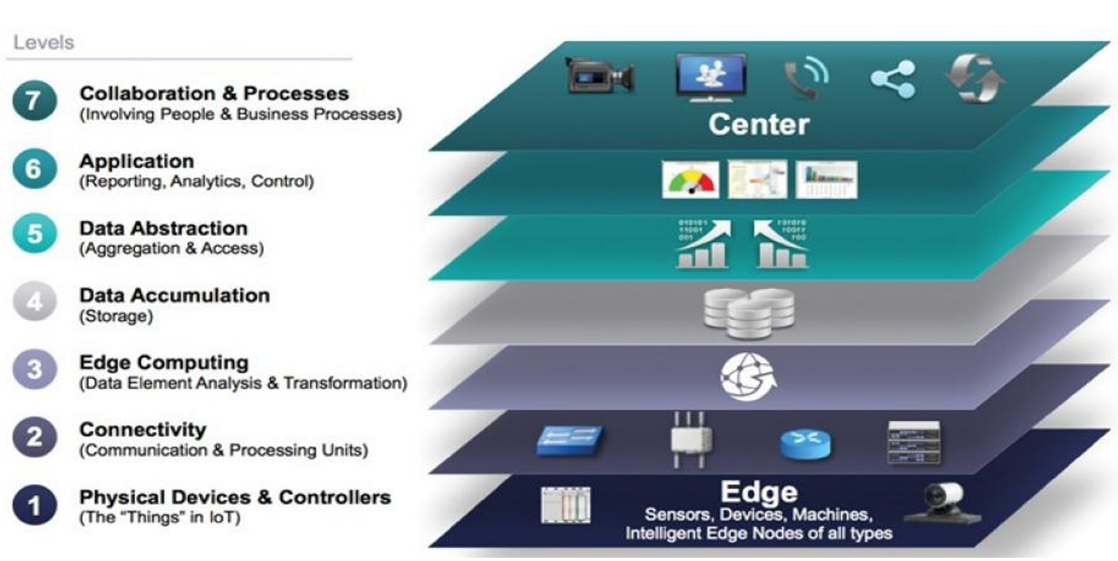

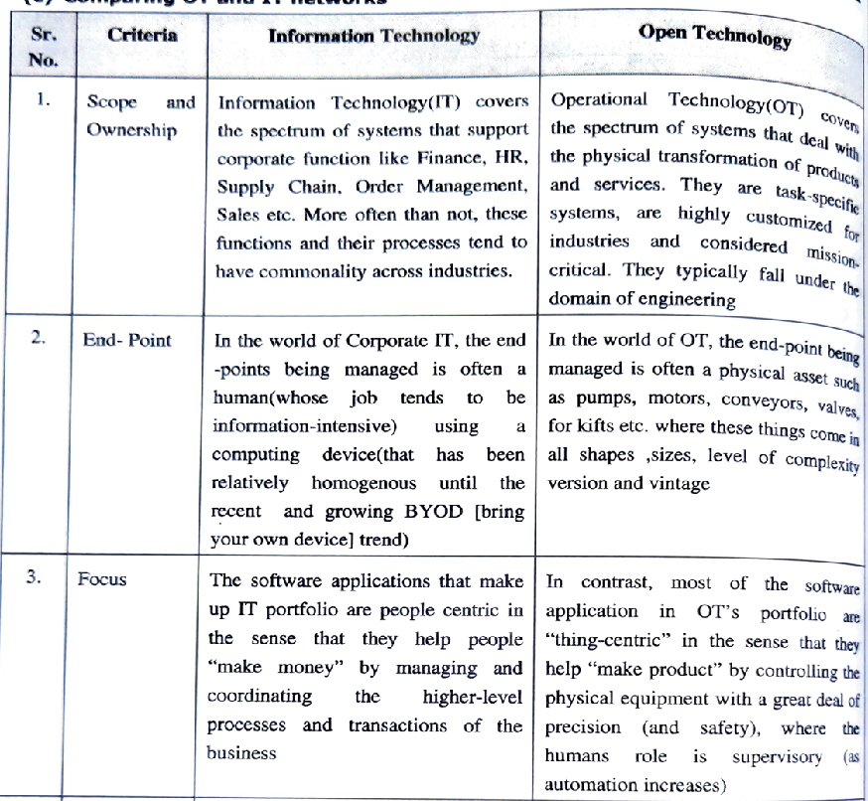

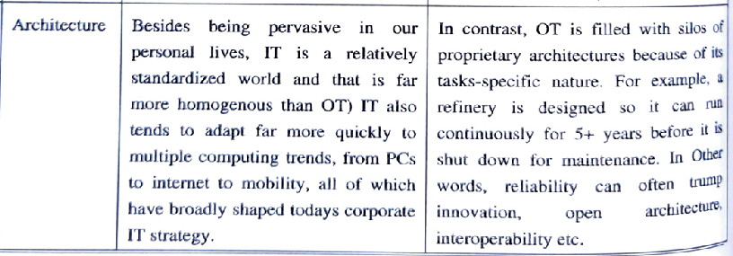

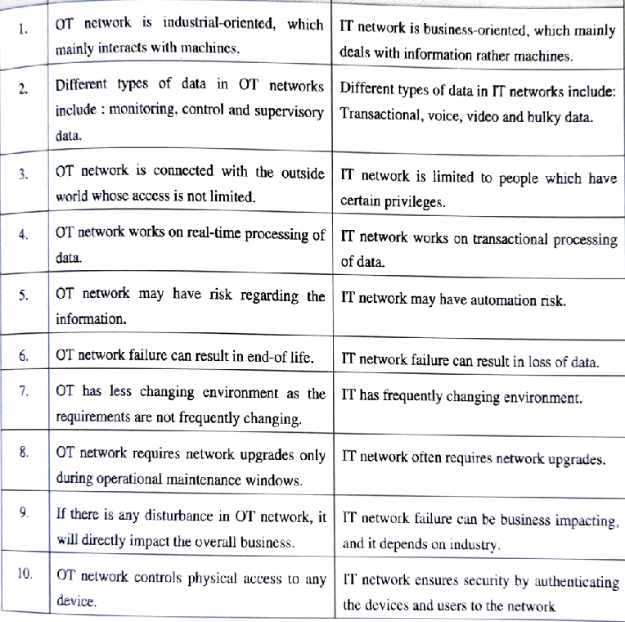

Simplified IOT architecture

1. The Core IoT Functional Stack
2. The IoT Data Management and Compute Stack

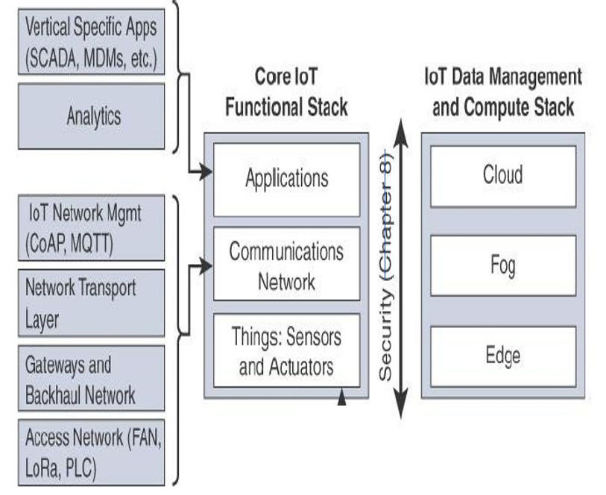

| **Aspect** | **Data Analytics** | **Network Analytics** |
| --- | --- | --- |
| Scope | Focuses on analyzing and deriving insights from data, often unstructured, to make informed decisions and discover trends. | Concentrates on monitoring and analyzing network data and traffic, including network performance, security, and anomalies. |
| Data Source | Sources of data may include databases, web data, user interactions, and sensors. Data is often diverse and may not be real-time. | Gathers data from network devices, routers, switches, and traffic flows. Network data is typically real-time or near-real-time. |
| Goals | Aims to extract valuable information, patterns, and trends from data for decision-making, business optimization, and predictive analysis. | Primarily seeks to ensure the network's efficiency, security, and reliability, detecting issues, and improving network performance. |
| Applications | Used in various domains, such as business intelligence, marketing, finance, healthcare, and IoT, for tasks like predictive maintenance and customer analysis. | Applied in network management, security, troubleshooting, and optimization, including tasks like identifying network threats and traffic management. |
| Techniques | Employs a range of techniques, including machine learning, data mining, statistical analysis, and visualization tools. | Relies on methods such as packet capture, flow analysis, and anomaly detection, along with network performance metrics. |
| Data Types | Analyzes structured and unstructured data, text, numbers, and multimedia, depending on the application. | Analyzes structured network data like IP addresses, packet headers, and traffic patterns. |
| Tools and Software | Uses software and tools like Python, R, SQL, Hadoop, and various data visualization platforms. | Employs network monitoring and analysis tools, such as Wireshark, Nagios, and commercial solutions like Cisco DNA Center. |
| Key Metrics | Metrics revolve around data quality, business KPIs, customer behavior, and data patterns, e.g., customer churn rate or revenue growth. | Metrics include network latency, bandwidth utilization, packet loss, device uptime, security threats, and network congestion. |
| User Base | Data analysts, data scientists, business analysts, and professionals in various industries. | Network administrators, security analysts, IT professionals, and those responsible for network maintenance and optimization. |

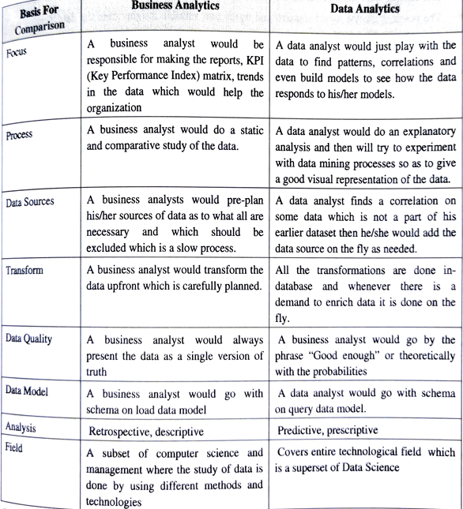

| **Aspect** | **Analytics Application** | **Control Application** |
| --- | --- | --- |
| Purpose | Focuses on analyzing and deriving insights from data to inform decision-making, identify trends, and provide recommendations. | Concentrates on actively managing and controlling processes, devices, or systems based on real-time data and predefined rules or algorithms. |
| Data Analysis | Involves retrospective and predictive data analysis to gain insights, discover patterns, and make informed decisions. | Involves real-time monitoring and decision-making, often with a focus on maintaining system performance and safety. |
| Type of Data | Analyzes historical and often large volumes of data, including both structured and unstructured data, to understand past and future trends. | Relies on real-time data and feedback, primarily structured data, to make immediate control decisions. |
| Applications | Used in various domains, such as business intelligence, marketing, finance, healthcare, and IoT, for tasks like predictive maintenance, customer analysis, and optimizing operations. | Applied in real-time process control, automation, and monitoring in industries like manufacturing, energy, robotics, and autonomous systems. |
| Decision-Making Timing | Provides recommendations or insights that can influence future decisions and strategic planning. | Makes immediate decisions based on current data to control devices, systems, or processes in real time. |
| Examples | - Predictive maintenance: Analyzing machine data to determine when equipment is likely to fail. - Customer segmentation: Grouping customers based on behavior for targeted marketing. | - Industrial automation: Controlling the operation of robots on an assembly line. - Autonomous vehicles: Steering and navigating a self-driving car in real-time based on sensor data. |
| Data Feedback | Provides feedback for informed decision-making, but the decisions themselves are often made by humans or other systems. | Uses real-time data as feedback to actively control devices or processes, often with minimal human intervention. |
| Tools and Software | Utilizes tools and software for data analytics, including data mining, machine learning, and visualization tools. | Employs control systems and software, often involving control algorithms, logic controllers, and automation platforms. |
| User Base | Data analysts, data scientists, business analysts, and professionals across various industries. | Control engineers, automation specialists, process operators, and those responsible for real-time system management. |
| Focus on Real-Time | Primarily focused on analyzing historical and predictive data, with a time horizon that extends beyond the immediate moment. | Primarily focused on real-time control and decision-making, with a focus on the here and now. |